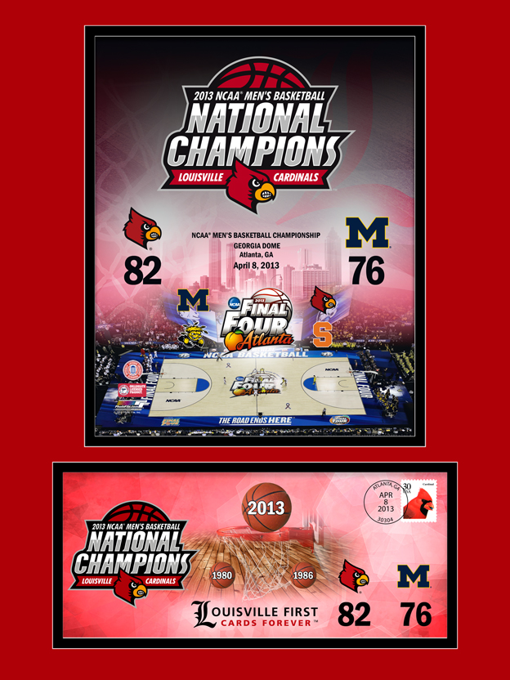

**KENTUCKIANA DISTRICT**

**UNIVERSITY OF LOUISVILLE**

**NCAA Men’s Basketball Championship**

**Matted Art and Cachet**

**&**

**Women’s Final Four**

**Cachet**

**Order Form**

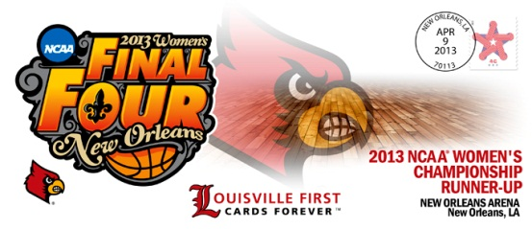

PLEASE PRINT AND FILL OUT COMPLETELY

First Name____________________________________________

Last Name____________________________________________

Mailing Address________________________________________ City__________________________________________________

State_______________ ZIP_______________________________

**Matted Art** $30.00 each + $10.00 S&H flat fee*

Quantity________

Cost $25 each____________

Total____________

**Commemorative Envelope** $10.00 + $3.00 flat fee*

Men’s Quantity_______ Women’s Quantity_______

Cost__________

Total__________

Total Cost to include shipping fee $_________

Please send orders via check or Postal Money order payable to Postmaster to:

Christy Brumfield-Retail Manager

PO Box 31611

Louisville, KY 40231

For information or questions, please contact Christy Brumfield at [christy.r.brumfield@usps.gov](mailto:christy.r.brumfield@usps.gov)   
or (502) 454-1991

**\*If both items are purchased, the shipping is a one-time fee of $10.00. Please allow 30 days for processing.**